BABY CLASS LESSON NOTES .

HEALTH HABITS

**WK 1**

Orientation

**Week 2**

**Content**

**PD1**  Body parts

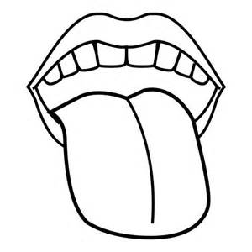Match the same body parts

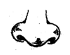

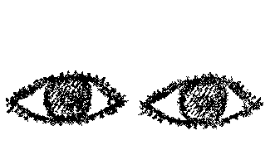



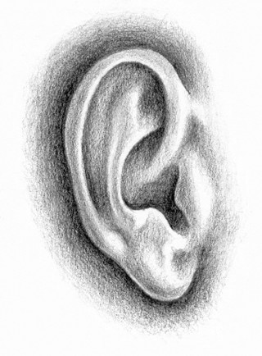





**Activities**

Identification of body parts

Matching

**PD2**

**Content**

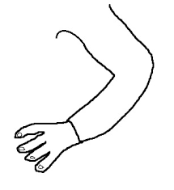Tell the body parts

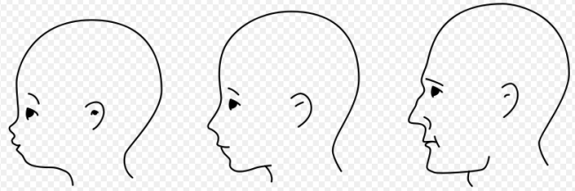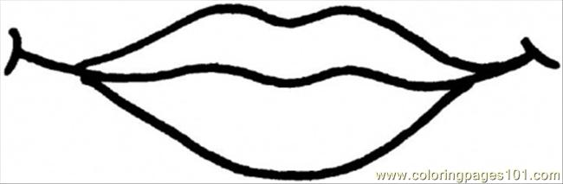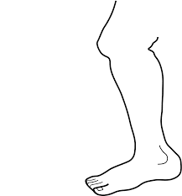

**Activities**

Identifying

Telling body parts names

Telling the use o different body parts

**WEEK 2**

**PD 1**

Interpreted the pictures

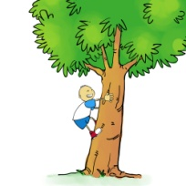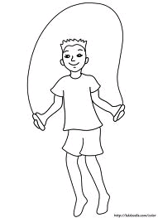

Following instructed actions

**WEEK 2**

**PD 2**

**Content**

Ways of caring for my body. (orally)

* Brushing teeth
* Combing hair
* Washing my face
* Bathing

ACTIVITIES

Practicing how to wash, brush, comb different body parts

**WEEK 3**

**Content**

**PD1**

Thing we use to clean the body

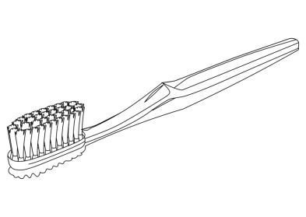**Match the same**

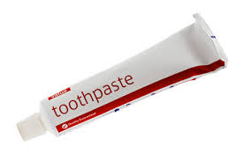



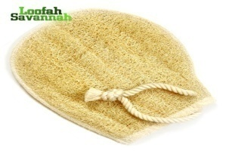

**Activities**

Matching the same things we us to clean our body.

* Identifying
* Naming

**PD 2**

**Content**

Say and circle the same.

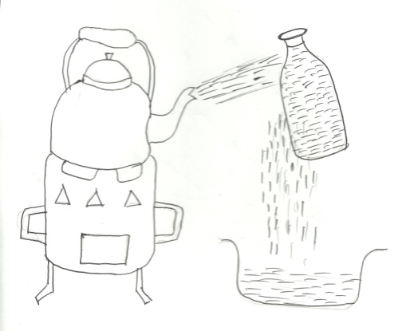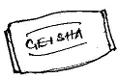

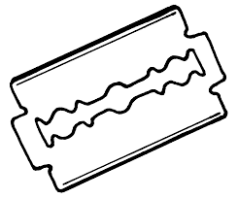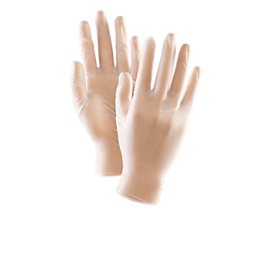

**Activities**

Circling the same

Identifying

Taking about their dangers

**WEEK 4**

**Content**

Things we wear

Shade the same

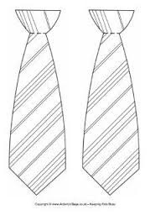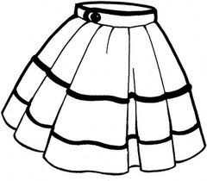

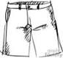

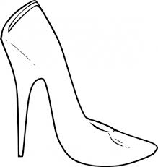

Shading

Identifying

**Content**

**PD 2**

Match to the belongings

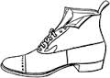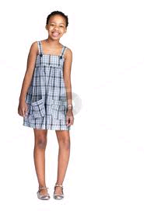

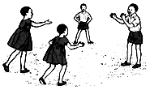



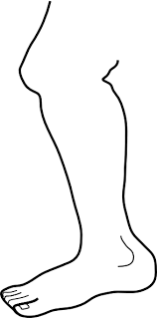

**Activities**

Matching

Identifying

**WEEK 5**

**PD 1**

Dangerous objects

Tell the dangerous objects

**Activities**

Telling names of dangerous objects

Talking about them hose their dangerous

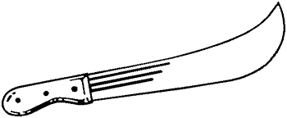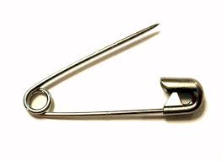

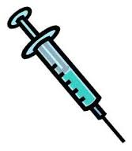

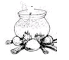

**PD 2**

**Content**

Circle the odd man out.

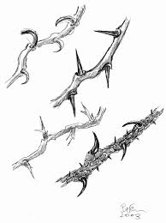

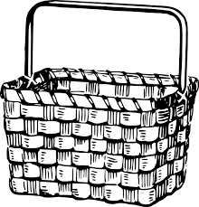

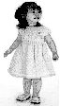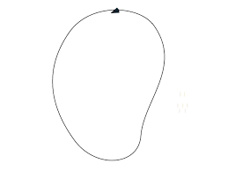



**WEEK 6**

PD1

Content

Match the same.

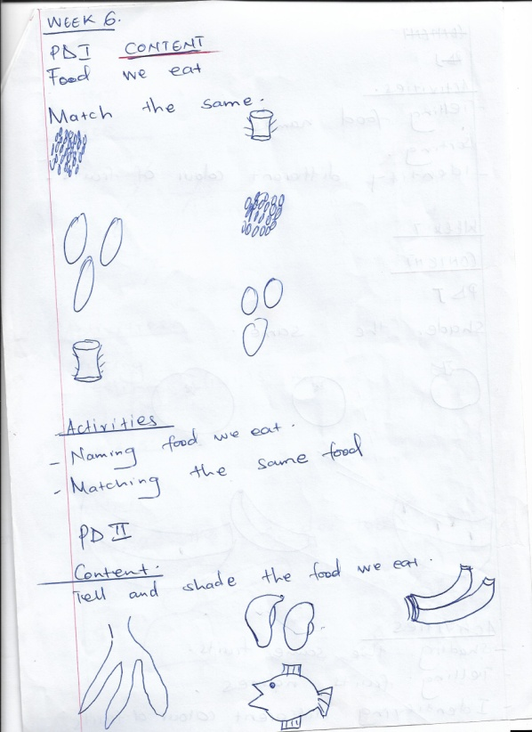

**Activities**

Naming food we eat.

Matching the same food.

**PD 2**

**Content**

Tell and shade the food we eat.

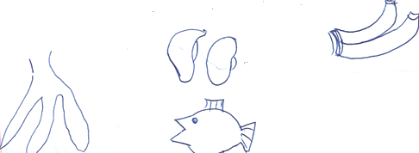

**Activities**

Telling food names

Sorting

Identifying different colour of fruits

**Week 7**

Colours

**PD1**

Shade the same.

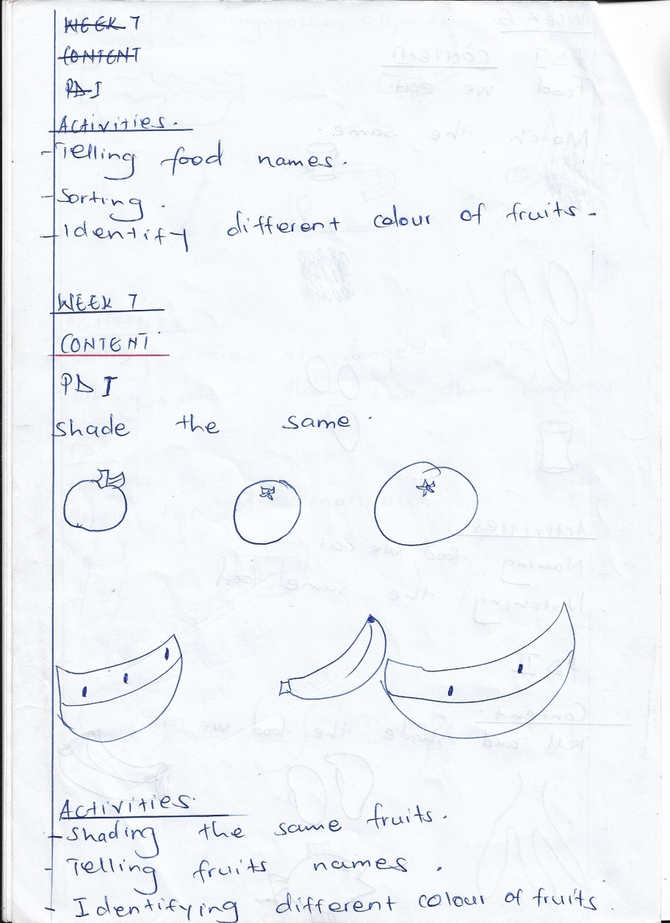

**Activities**

Shading the same fruits

Telling fruits names

Identifying different colour of fruits.

**PD 2**

**Content**

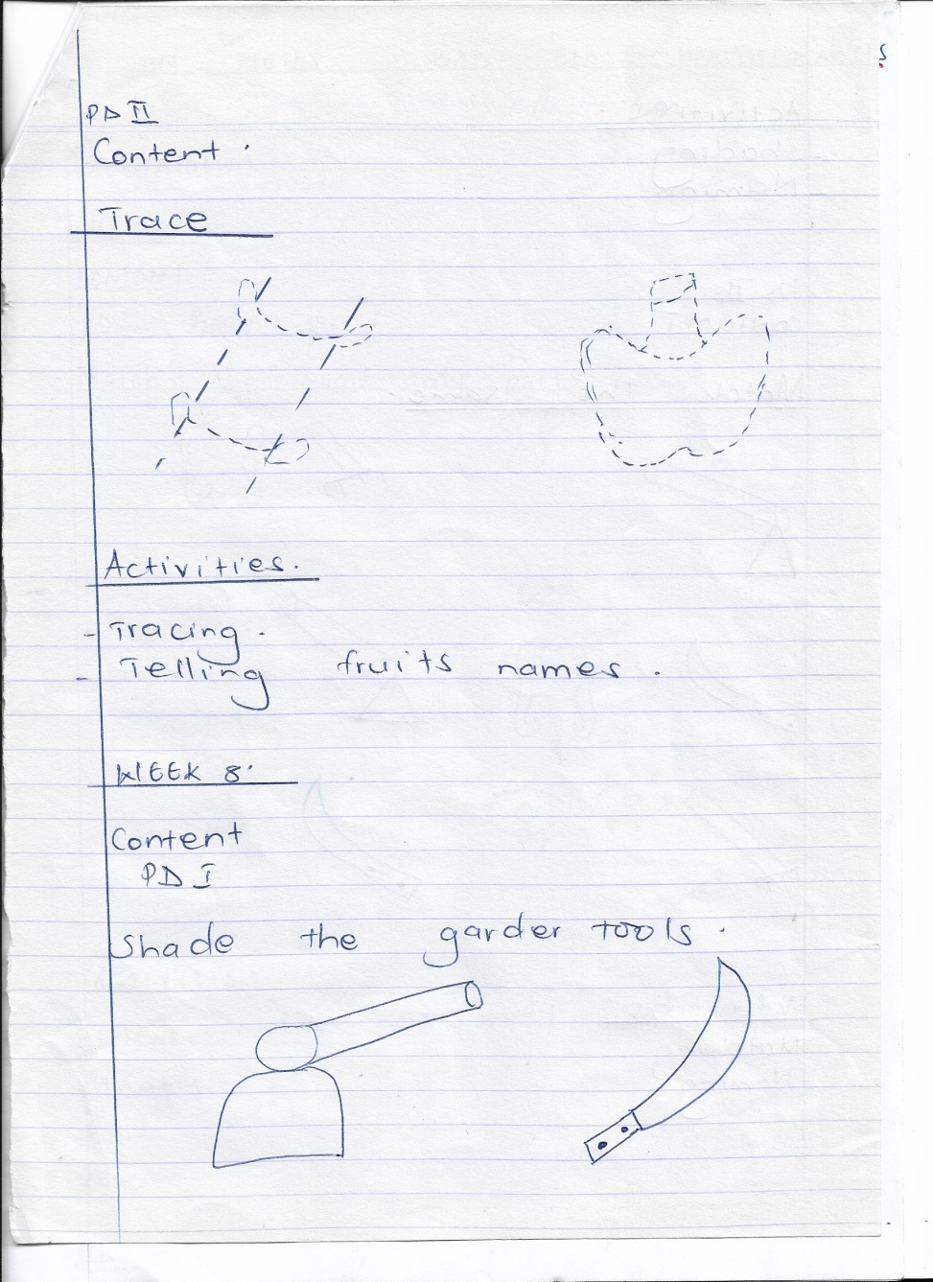Trace

**Activities**

Tracing

Telling fruits names.

**Week 8**

**PD 1**

Shade the garden tools.

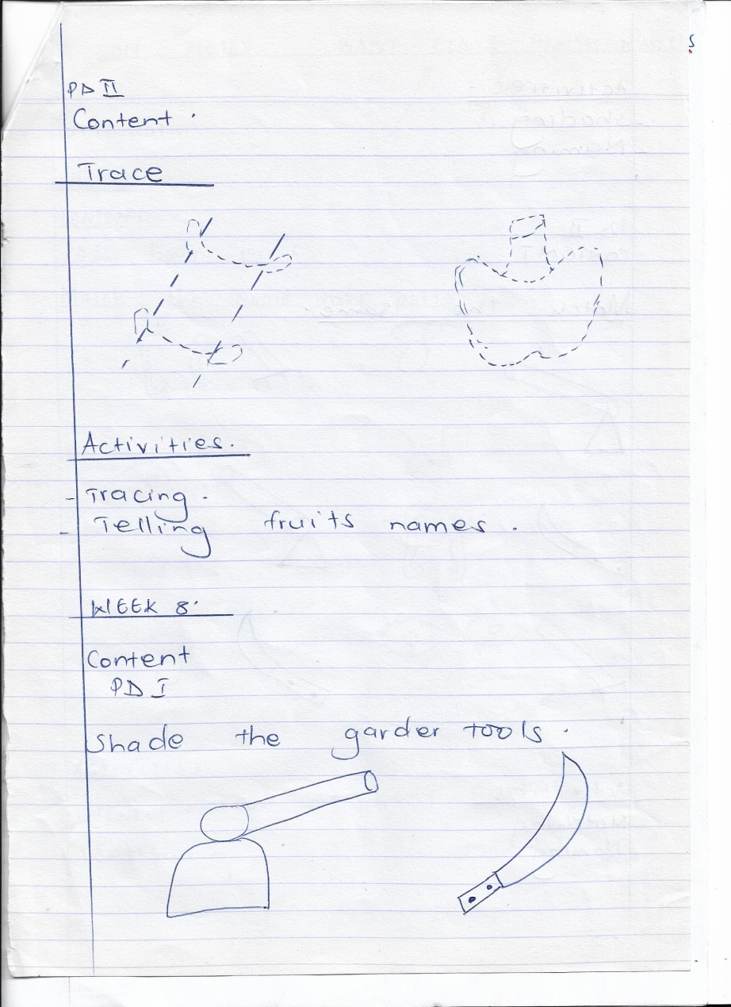

**Activities**

Shading

Naming

**PD 2.**

**Content**

Match the same.

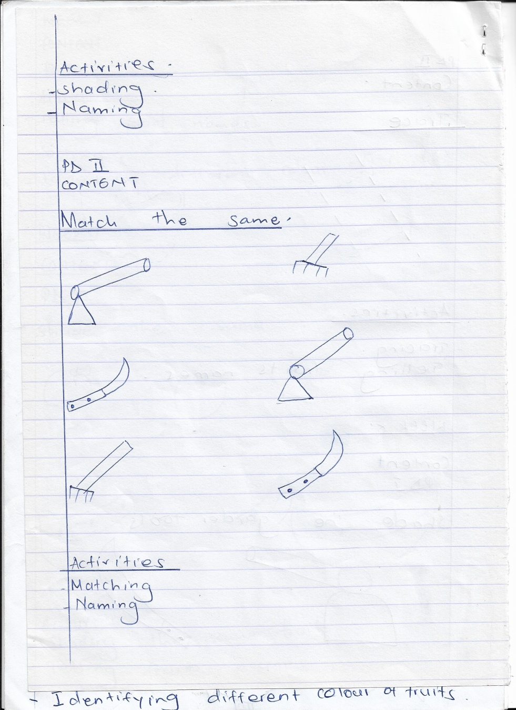

**Activities**

Matching

Naming